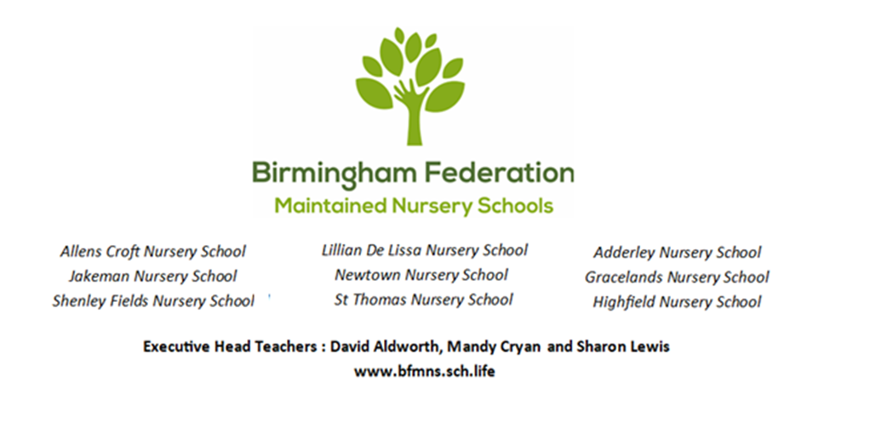
Data Privacy Notice
Allens Croft and Shenley Fields Nursery Schools

How we use pupil information

Why do we collect and use pupil information?
We collect and use pupil information under our legal obligation to section 537A of the Education Act 1996.

We use the pupil data:
• to support pupil learning.
• to monitor and report on pupil progress.
• to provide appropriate pastoral care.
• to assess the quality of our services.
• to comply with the law regarding data sharing.

The categories of pupil information that we collect, hold and share include:

• Personal information (such as name, unique pupil number, date of birth and address, emergency contact details).
• Characteristics (such as ethnicity, language, nationality, country of birth, early years pupil premium entitlement and free school meal eligibility).
• Attendance information (such as sessions attended, number of absences and absence reasons). • Funding (EEE for 2 and 3-year-old children, 30 hours, EYPP, DAF, NI).
• Medical information (such as allergies and other conditions, regular medication needed, NHS number)
• Special educational needs information (professional involvement, category of need, support plans etc.)
• Assessment information (such as things they can do or need help with, where they are working on the Early Years Foundation Stage curriculum).
• Safeguarding incidents (such as disclosures from children and/or families, current or historic social care intervention, child in need plans, child protection plans, looked after children).
• Behavioural information.
• Day to day internal logs (safe sleep records, accidents, school meal data, changing charts, permission slips – sun cream, photographs, emergency medical treatment etc.).

Collecting Pupil Information
Whilst the majority of pupil information you provide to us is mandatory, some of it is provided to us on a voluntary basis. In order to comply with the General Data Protection Regulation, we will inform you whether you are required to provide certain pupil information to us or if you have a choice in this.

Storing Pupil Data
Most of the pupil data we hold will transfer with your child to their next school/setting when they leave us. We are required by law to retain some data for varying lengths of time. We follow the guidance in the Records Management Toolkit for Schools to do this.

Who Do We Share Pupil Information With?
We routinely share pupil information with:
• schools or nurseries that the pupil’s attend after leaving us.
• our local authority (Birmingham City Council) and their commissioned service partners.
• the Department for Education (DfE).

Why We Share Pupil Information
We do not share information about our pupils with anyone without consent unless the law and our policies allow us to do so. We share pupils’ data with the Department for Education (DfE) on a statutory basis. This data sharing underpins school funding and educational attainment policy and monitoring. We are required to share information about our pupils with our local authority (LA) and the Department for Education (DfE) under section 3 of The Education (Information About Individual Pupils) (England) Regulations 2013. The National Pupil Database (NPD) The NPD is owned and managed by the Department for Education and contains information about pupils in schools in England. It provides invaluable evidence on educational performance to inform independent research, as well as studies commissioned by the Department. It is held in electronic format for statistical purposes. This information is securely collected from a range of sources including schools, local authorities and awarding bodies.

We are required by law, to provide information about our pupils to the DfE as part of statutory data collections such as the school census and early years’ census. Some of this information is then stored in the NPD. The law that allows this is the Education (Information About Individual Pupils) (England) Regulations 2013.

The department may share information about our pupils from the NPD with third parties who promote the education or well-being of children in England by:

• conducting research or analysis
• producing statistics
• providing information, advice or guidance

The Department has robust processes in place to ensure the confidentiality of our data is maintained and there are stringent controls in place regarding access and use of the data. Decisions on whether DfE releases data to third parties are subject to a strict approval process and based on a detailed assessment of:

• who is requesting the data
• the purpose for which it is required
• the level and sensitivity of data requested: and
• the arrangements in place to store and handle the data

To be granted access to pupil information, organisations must comply with strict terms and conditions covering the confidentiality and handling of the data, security arrangements and retention and use of the data.

For more information about the department’s data sharing process, please visit:
https://www.gov.uk/data-protection-how-we-collect-and-share-research-data

To contact DfE: https://www.gov.uk/contact-dfe

Requesting Access to your Personal Data
Under data protection legislation, parents and pupils have the right to request access to information about them that we hold. To make a request for your personal information, or be given access to your child’s educational record, contact our Data Protection Officer (DPO), Tania Lane, who is based at Allens Croft Nursery School (0121 675 0362).

You Also Have the Right to:
• object to processing of personal data that is likely to cause, or is causing, damage or distress, • prevent processing for the purpose of direct marketing,
• object to decisions being taken by automated means,
• in certain circumstances, have inaccurate personal data rectified, blocked, erased or destroyed; and • claim compensation for damages caused by a breach of the Data Protection regulations.

If you have a concern about the way we are collecting or using your personal data, you should raise your concern with us in the first instance or directly to the Information Commissioner’s Office at
https://ico.org.uk/concerns/

Contact:
If you would like to discuss anything in this privacy notice, please contact our School Office Manager within the relevant school on the above numbers.

Date Policy Adopted by Local Committee: 06.12.2022
Date Policy Adopted by Full Governing Board: 16.01.2023
Date for next renewal: Autumn Term 2024

Signed: ____________________________ Sue Sidaway
Chair of Local Committee

Signed: ____________________________ Sean Delaney
Chair of Governors

Signed: ____________________________ David Aldworth
Executive Head Teacher

